*ALPER YILMAZ*

*CSSM 502 | Final Report*

*Unequal State capacıty at subnatıonal level*

1. **Introduction**

Why do some states develop equal state capacity, thereby evenly distributing state resources across their territories, while others do not? Despite having strong capabilities at the national level, does it have a different level of state capacity at the sub-national level? Why could it not be developed equally across provinces? As the most basic institution of political life, the state has many important obligations to its citizens. The source of liability lies essentially in the fact that citizens pay taxes. Tax-paying citizens expect their state to do something to keep their lives social and healthy. But in order to be able to carry out these tasks properly, the state must have some power. Without sufficient power, the state can become an institution that fails to deliver what its citizens expect and, in a sense, loses its legitimacy in the eyes of its citizens. In fact, this power derives from the state's ability to govern its territory by controlling and penetrating society.

In this regard, scholars use state capacity in the literature as a concept to describe and compare state strength. Scholars use different conceptualizations or operationalizations of state capacity (Hanson and Sigman 2021), and describe variations of different mechanisms based on state capacity (Cingolani 2018). At the same time, scholars are analyzing why state capacity varies from country to country. However, they mostly ignore the reasons for subnational variation in state capacity (Luna and Soifer 2017). Just as state capacity varies from country to country, it also varies within countries. Why states have different capacities is more understandable, but why the state has different capacity across the territory is more puzzling. Therefore, the main questions this study raises and attempts to answer from a theoretical perspective are: Why does state capacity vary across territories? What are the consequences of this variation?

Consequently, in this research, my main aim is to examine and locate the reason for the unequal state capacity in the territory in the case of the Republic of Turkey. The main argument of this research that explains the reason for the failure to develop equal state capacity over the territory is the existence of territorial challengers during the state formation process. This argument basically claims that during the state formation process, because of the territorial challengers who inhibited the state projection of the state elite by challenging with the armed forces for the aim of creating an independent state from the state who seeks to centralize the power, the state could not develop insufficient state capacity over the provinces where the territorial challengers existed.

Therefore, my main goal in this study is to investigate and find out the reasons for unequal state capacity within the territory in the case of the Republic of Turkey. A major argument in this study to explain the failure of territorial equal national capacity development is the presence of territorial challengers in the process of state formation. This argument basically claims that during the state formation process, because of the territorial challengers who inhibited the state projection of the state elite by challenging with the armed forces with the aim of creating an independent state from the central state, the state could not develop insufficient state capacity over the provinces where the territorial challengers existed.

1. **Literature Review**

As I stated in the introduction, few scholars have investigated the causes of unequal state capacity at the subnational level. Scholars focused primarily on the reasons for differences in state capacity across countries. Scholars who study differences in state capacity in one territory generally agree that the uneven state capacity based on the conceptualization of state presence over the territory stems from societal forces' noncompliance with the central authority in Latin American countries (Migdal 1988; O'Donnell 1993; Whitehead 1995) and African countries (Herbst 2000; Boone 2003). More recent studies have found similar findings regarding the relationship between state capacity and societal forces' noncompliance. These studies primarily suggest that the reason for unequal state capacity over territory is due to societal forces' noncompliance, and they primarily demonstrate the inequality of capacity over territory based on public goods provision (Chadha and Nandwani 2018; Giraudy and Luna 2017; Gao 2016; Singh and vom Hau 2016; Soifer 2015). In this sense, because my research examines the relationship between societal forces' noncompliance, i.e., territorial challengers, and state capacity, which I conceptualize as a territorial reach based on public goods provision, it fits into this literature. This literature is relatively new in the political science literature in the sense that subnational comparison is gaining importance in the last decade because it provides more systematic causality between variables (Soifer 2019). As a result, by examining the case of Turkey, my research will contribute to the literature in this regard.

1. **Research Design and Findings**

As I stated above, I examine the level of state capacity based on the public goods provision as compatible with the literature. My main aim is to demonstrate the unequal state capacity in the Turkish territory based on spatial analysis with data regarding public goods provision. My primary expectation is that the state capacity is underdeveloped in provinces where territorial challengers organized revolt during the state formation process of the Turkish state. I identify the state formation years for Turkey as the years between 1923 and 1938. During these years, the Turkish political elite aimed to centralize the authority. However, the Kurds challenged this effort of the Turkish political elite by organizing 18 revolts that aimed to create an independent state. Consequently, the Turkish state, which had skeptical attitudes toward the Kurds and mostly Kurdish-populated provinces, could not develop equal state capacity over these provinces compared to others. To demonstrate this relationship, I use the spatial analysis technique.

In order to show provinces where revolts occurred, I collected data regarding the location of revolts from Genelkurmay Belgelerinde Kürt İsyanları (Hâllı 1992). I coded the revolts variable as a binary variable taking 1 if a revolt occurred in a province or 0 otherwise. Figure 1 demonstrates the provinces where revolts occurred in the years between 1923 and 1938. As is seen in Figure 1, all of the revolts occurred in the east of Turkey. Currently, most of the Kurdish people reside in these provinces.

Figure 1 The Provinces where Revolts occurred in the years between 1923 - 1938

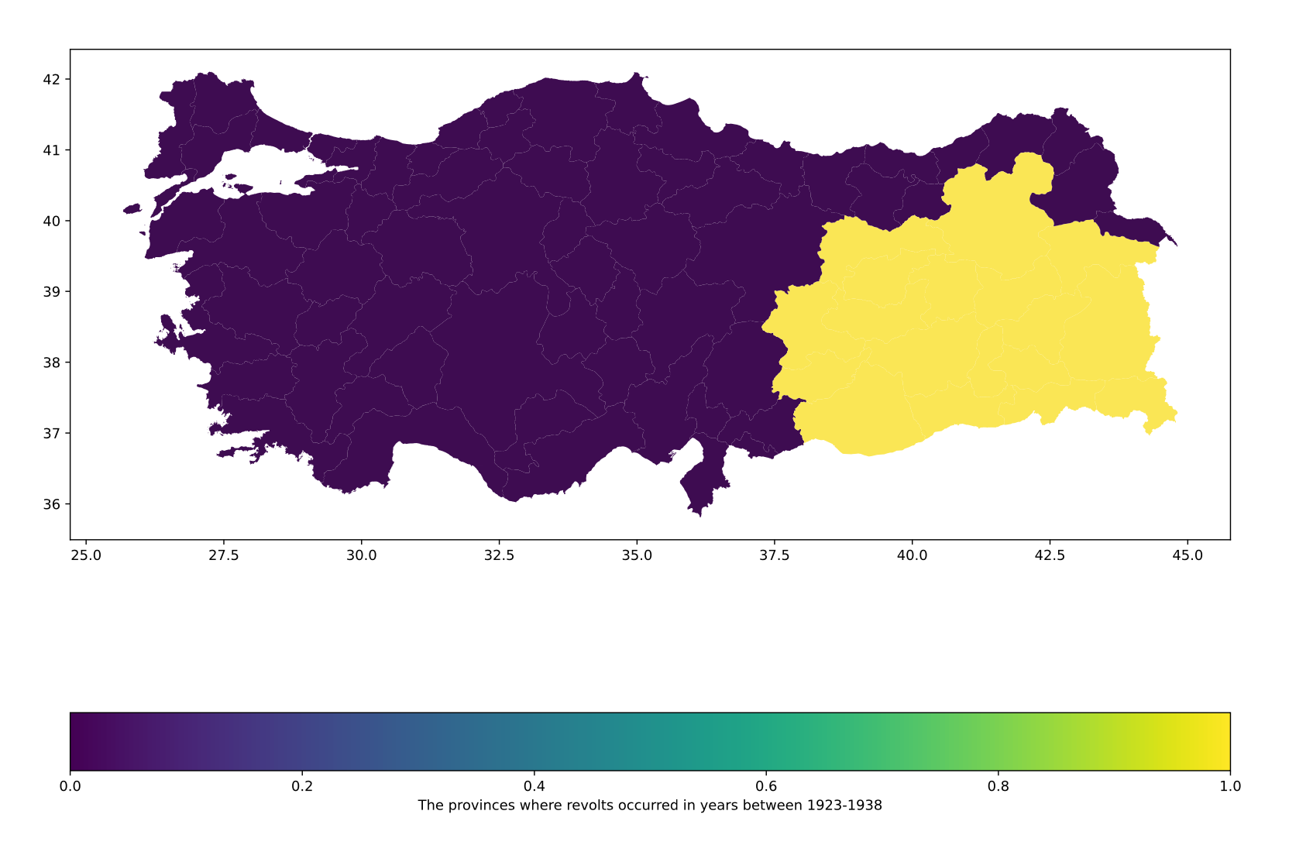

Therefore, my expectation is that the public goods provision regress toward the east of Turkey. In order to demonstrate this regression, I use six different variables. I examine the public goods provision based on three sectors: health, education, and justice. Therefore, variables that I use for these sectors are the number of hospital beds per 100.000 people, the number of public hospitals per 100.000 people, the number of doctors per 100.000 people, the number of schools per 100.000 5-9 aged people, the number of classes per 100.000 5-9 aged people, and the number of crimes per 100.000 people. I collected these variables from TÜİK[1]. Consequently, I use these six to demonstrate the variation in the level of state capacity in provinces.

Maps 2 to 7 show the variation of the public goods provision. While the blue color indicates the low level, the yellow color indicates the high level for these variables. As is seen from maps, except for the number of crimes per 100.000 people, the level of other variables is low in most provinces of the eastern part of Turkey. Although these low-level provinces do not match perfectly with provinces where the revolts occurred, the regression of the level from the western part of Turkey to the eastern part supports my expectation regarding the relationship between the territorial challengers and the unequal state capacity. The only variable that does not support my expectation is the number of crimes per 100.000 people because the level of crime increases from the eastern to the western part of Turkey. My expectation was the contrary. The reason for that would be that the Turkish state’s police forces over the eastern provinces might not be strong enough as much as in the western part of Turkey to detect and capture criminals.

1. **Conclusion**

As a result, in this research, by using spatial analysis, I analyzed my theoretical expectation. My argument basically suggests that during the state formation process, since territorial challengers organized revolts to create an independent state, the state could not develop equal state capacity over the territory. In order to test this expectation, I choose the Republic of Turkey as a case, and I measure the state capacity based on the public goods provision of three sectors, which are health, education, and crime. I collected data from TÜİK, and the variables I used are the number of hospital beds per 100.000 people, the number of public hospitals per 100.000 people, the number of doctors per 100.000 people, the number of schools per 100.000 5-9 aged people, the number of classes per 100.000 5-9 aged people, and the number of crimes per 100.000 people. Consequently, the findings based on the spatial analysis support my theoretical expectation. The level of public goods provision basically decreased from the western part to the eastern part of Turkey, where the territorial challengers organized revolts during the years between 1923 and 1938.

Figure 2 The Number of Hospital Beds per 100.000 people

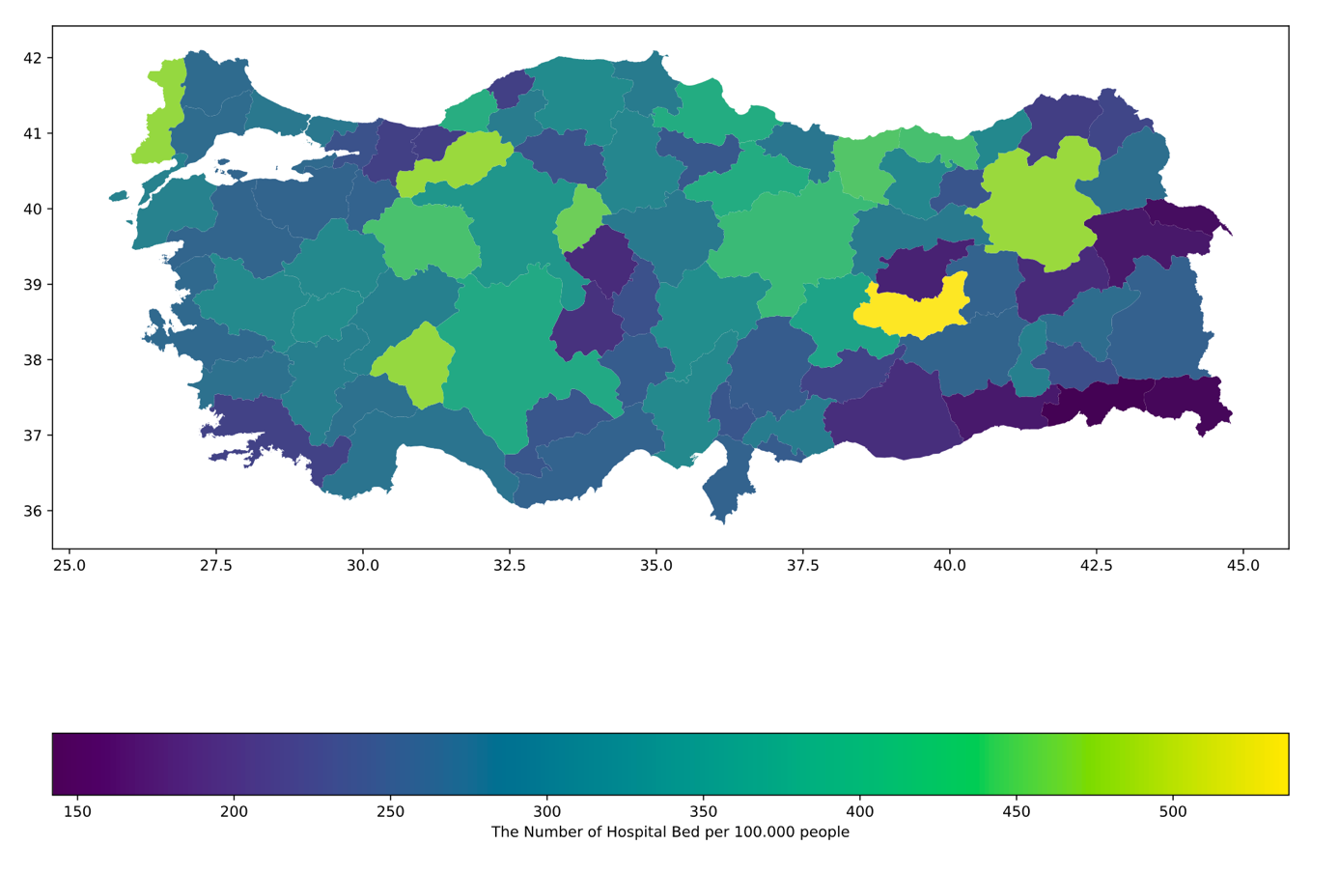

Figure 3 The Number of Public Hospitals per 100.000 people

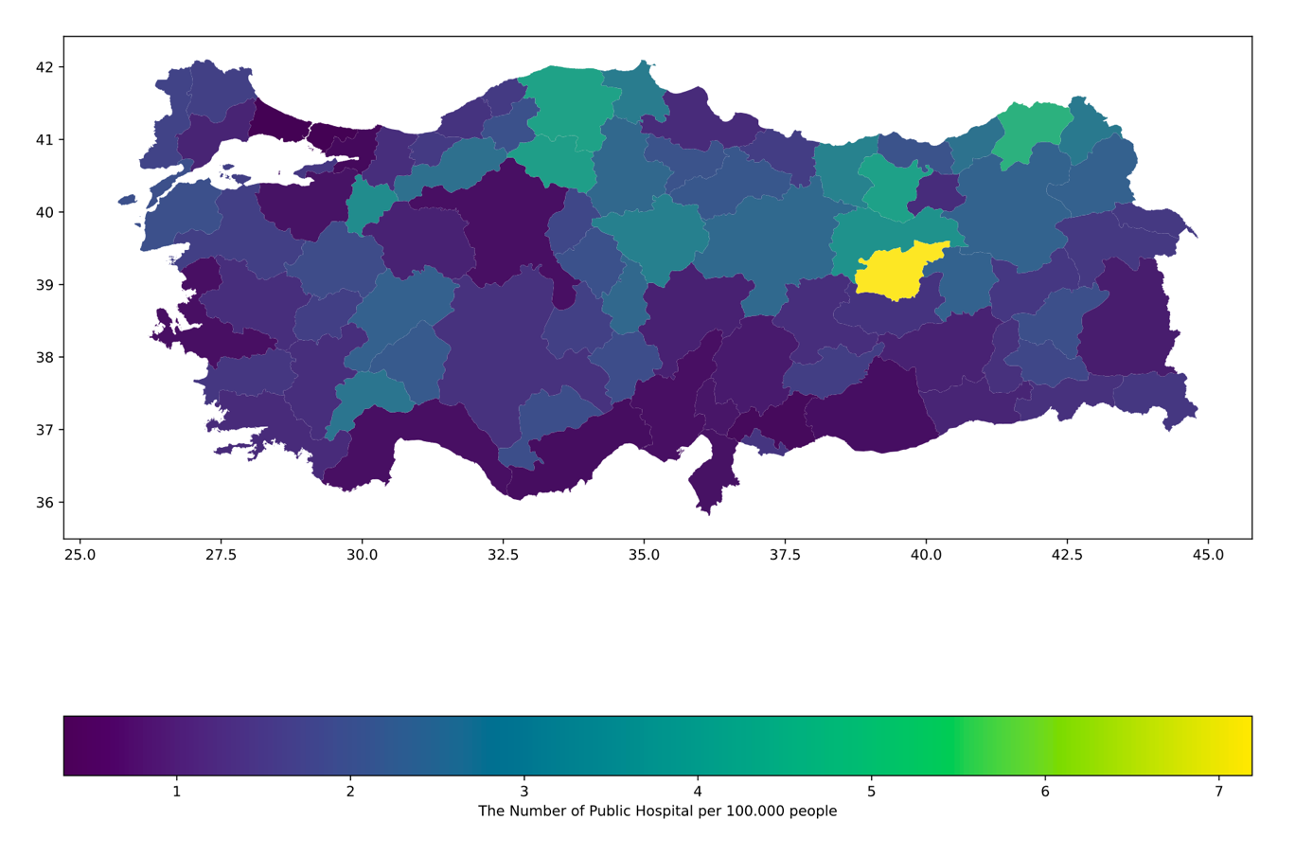

Figure 4 The Number of Doctors per 100.000 people

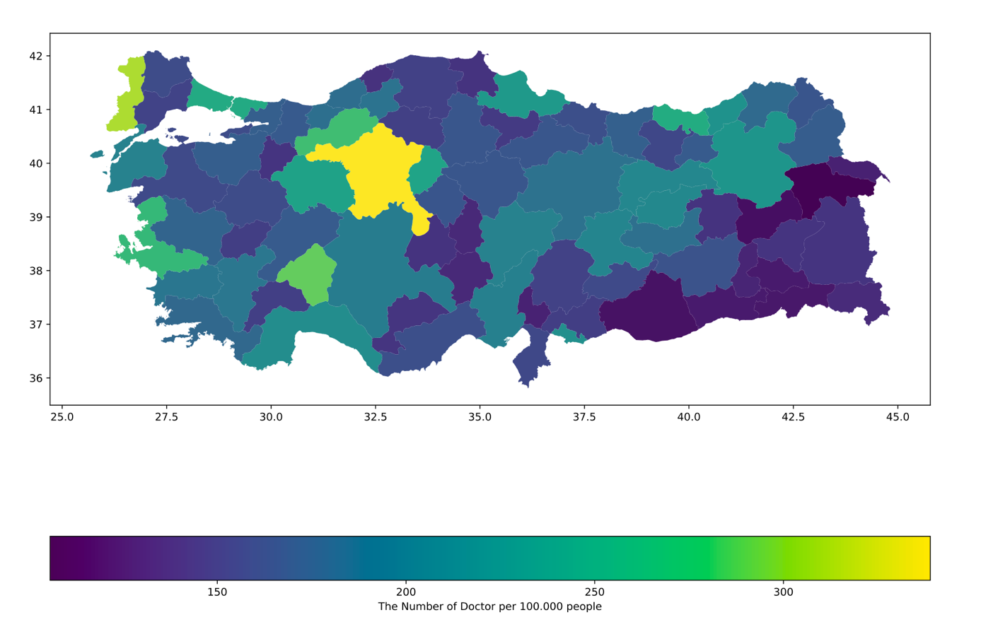

Figure 5 The Number of Schools per 100.000 5-9 aged people

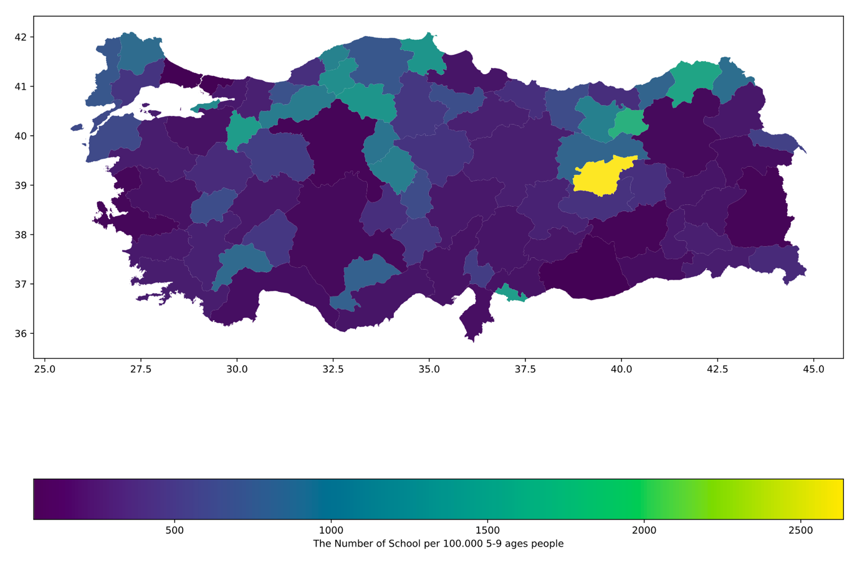

Figure 6 The Number of Classes per 100.000 5-9 aged people

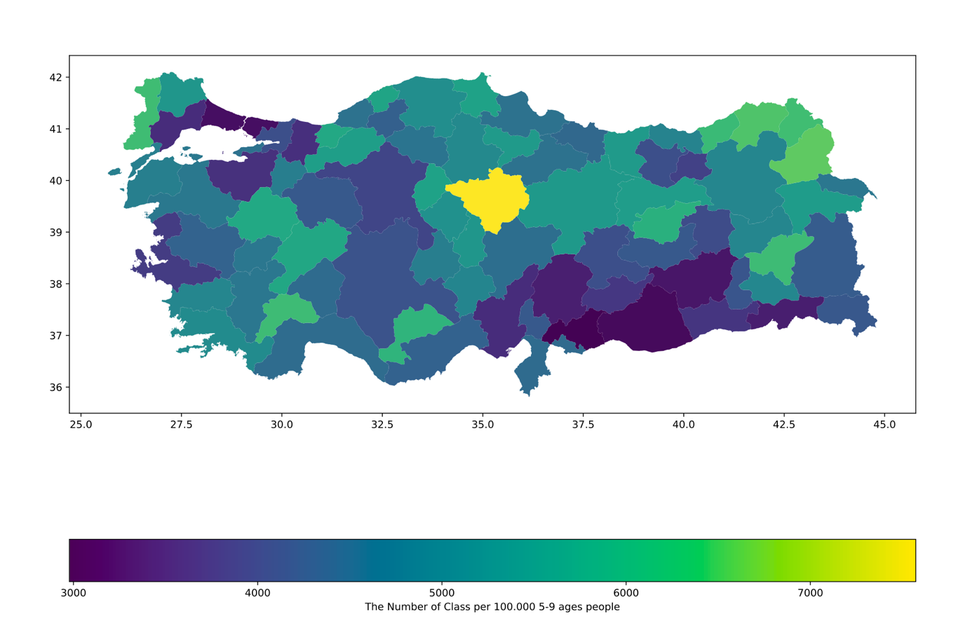

Figure 7 The Number of Crimes per 100.000 people

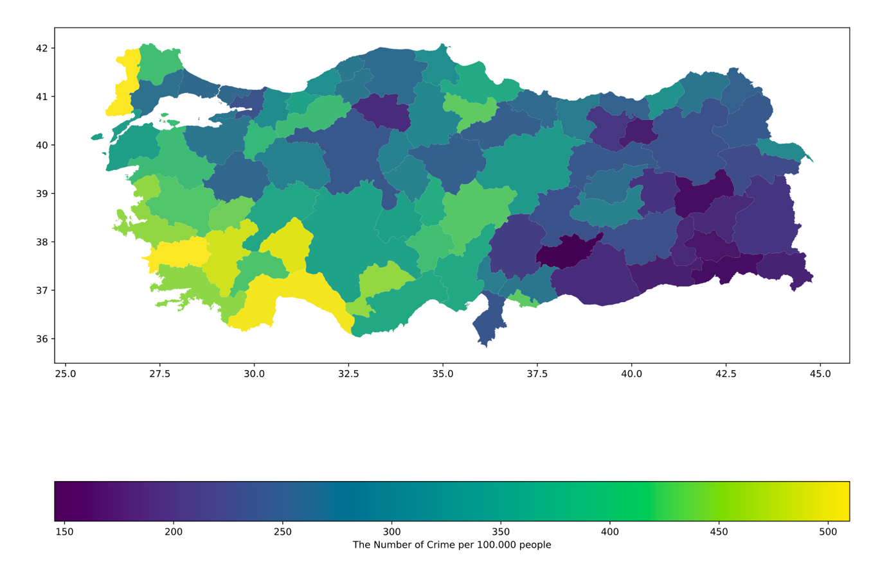

Boone, Catherine. 2003. *Political Topographies of the African State: Territorial Authority and Institutional Choice*, *Cambridge Studies in Comparative Politics*. Cambridge: Cambridge University Press.

Chadha, Nishant, and Bharti Nandwani. 2018. "Ethnic Fragmentation, Public Good Provision and Inequality in India, 1988–2012." *Oxford Development Studies* 46 (3):363-377.

Cingolani, Luciana. 2018. "The Role of State Capacity in Development Studies." *Journal of Development Perspectives* 2 (1-2):88-114.

Gao, Eleanor. 2016. "Tribal Mobilization, Fragmented Groups, and Public Goods Provision in Jordan." *Comparative Political Studies* 49 (10):1372-1403. doi: 10.1177/0010414015621075.

Giraudy, Agustina, and Juan Pablo Luna. 2017. "Unpacking the State’s Uneven Territorial Reach: Evidence from Latin America." In *States in the Developing World*, 93-120. Cambridge: Cambridge University Press.

Hâllı, Reşat. 1992. *Genelkurmay Belgelerinde Kürt İsyanları*. 3 vols, *CI, II, III*. İstanbul: Kaynak Yayınları.

Hanson, Jonathan K., and Rachel Sigman. 2021. "Leviathan’s Latent Dimensions: Measuring State Capacity for Comparative Political Research." *The Journal of Politics* 83 (4):1495-1510. doi: 10.1086/715066.

Herbst, Jeffrey. 2000. *States and Power in Africa Comparative Lessons in Authority and Control*. STU - Student edition, 2 ed. Princeton: Princeton University Press.

Luna, Juan Pablo, and Hillel David Soifer. 2017. "Capturing Sub-National Variation in State Capacity: A Survey-Based Approach." *American Behavioral Scientist* 61 (8):887-907. doi: 10.1177/0002764217720964.

Migdal, Joel S. 1988. *Strong Societies and Weak States: State-Society Relations and State Capabilities in the Third World*, *Princeton, New Jersey*: Princeton University Press.

O'Donnell, Guillermo. 1993. "On the State, Democratization and Some Conceptual Problems: A Latin American View with Glances at Some Postcommunist Countries." *World Development* 21 (8):1355-1369. doi: <https://doi.org/10.1016/0305-750X(93)90048-E>.

Singh, Prerna, and Matthias vom Hau. 2016. "Ethnicity in Time: Politics, History, and the Relationship between Ethnic Diversity and Public Goods Provision." *Comparative Political Studies* 49 (10):1303-1340. doi: 10.1177/0010414016633231.

Soifer, Hillel David. 2015. "Regionalism, Ethnic Diversity, and Variation in Public Good Provision by National States." *Comparative Political Studies* 49 (10):1341-1371. doi: 10.1177/0010414015617965.

Soifer, Hillel David. 2019. "Units of Analysis in Subnational Research." In *Inside Countries: Subnational Research in Comparative Politics*, edited by Agustina Giraudy, Eduardo Moncada, and Richard Snyder, 92-112. Cambridge: Cambridge University Press.

Whitehead, Laurence. 1995. "State Organization in Latin America Since 1930." In *The Cambridge History of Latin America: Volume 6: 1930 to the Present*, edited by Leslie Bethell, 1-96. Cambridge: Cambridge University Press.

1. https://biruni.tuik.gov.tr/bolgeselistatistik/anaSayfa.do